**Prepared by <**

**Abdelrahman Ahmed 42010611**

**Mostafa Hamza Hassan 42010521**

**Abanoub Ragheb Younan 42010601**

**>**

Level 0:

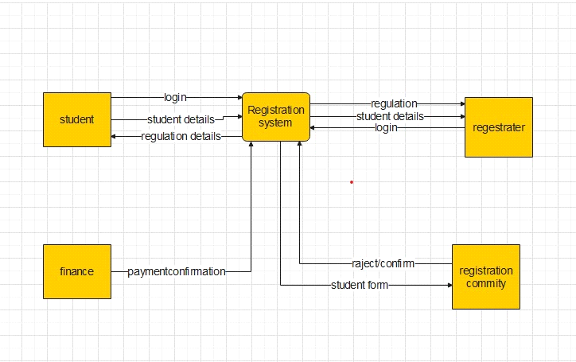

Level1:

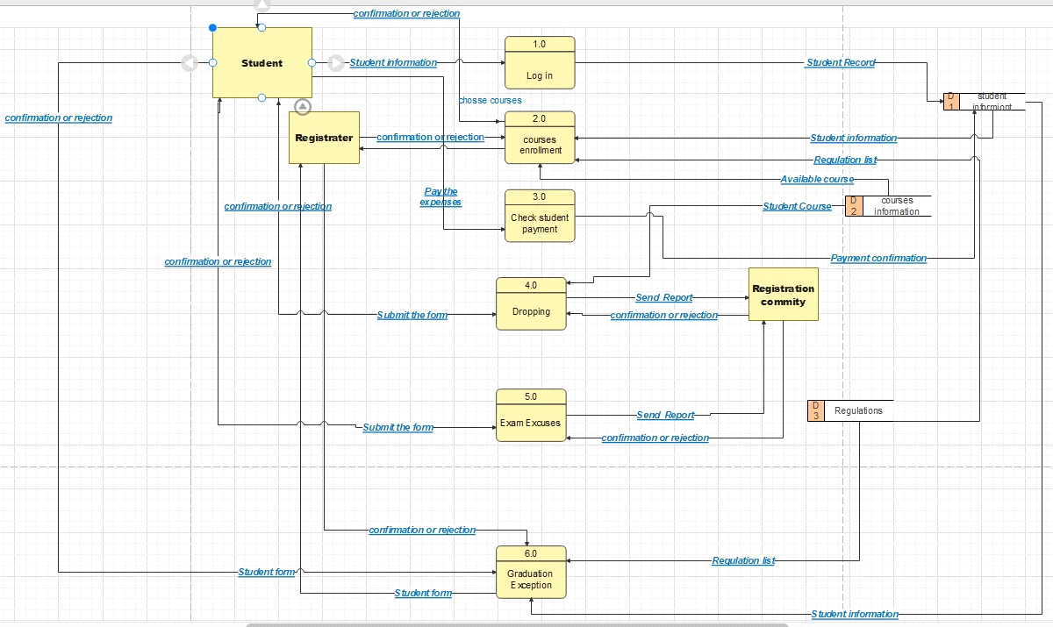

Level 2:

